Todor Tsekov, George Vasileiadis, Jiefan Lin

Group 6 |

Design Document

Trivia

Table of Contents

1. Architecture diagram 2

2. Interface description 2

2.1 Methods 2

2.2 Callbacks/Events 2

3. Class diagram 2

4. Sequence diagrams 3

4.1 Start game 3

4.2 Answer Question 4

4.3 Win/Lose/Draw 5

# Architecture diagram

# Interface description

## Methods

## Callbacks/Events

# Class diagram

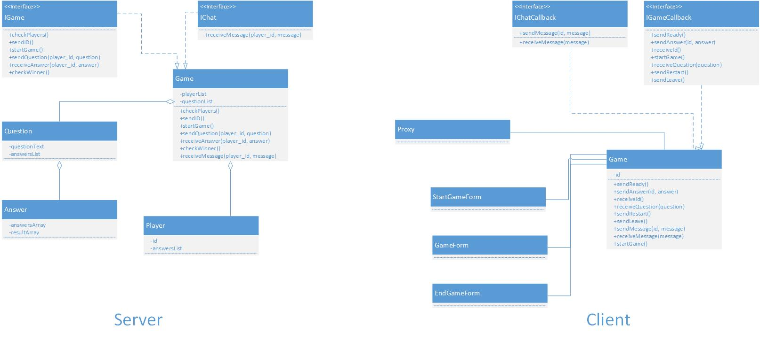

# Sequence diagrams

## 4.1 Start game

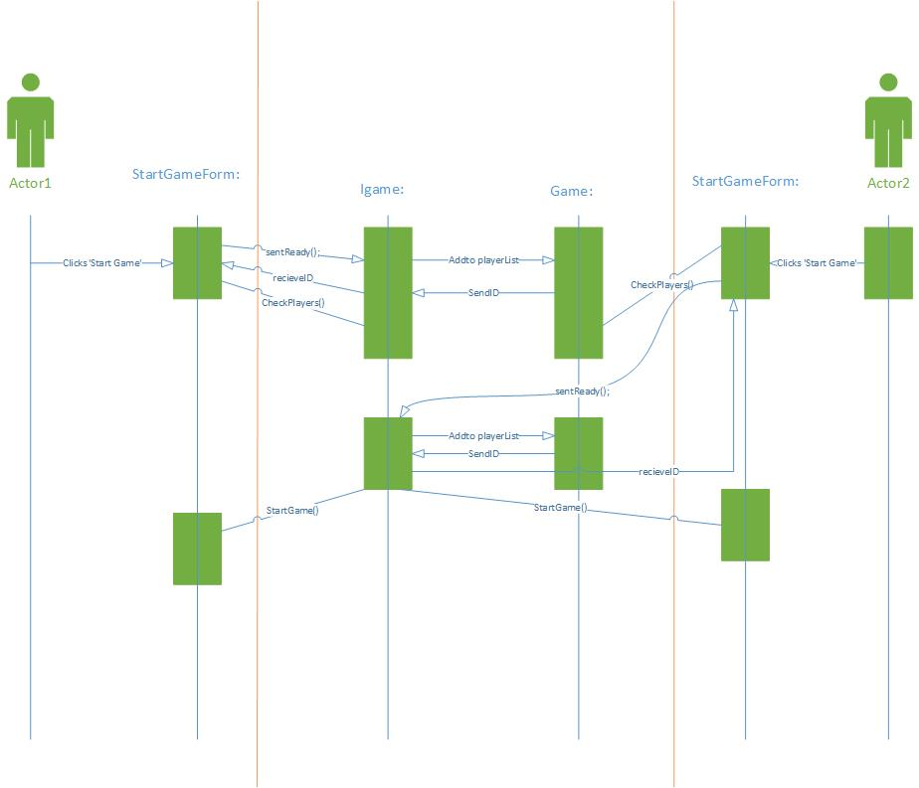

## 4.2 Answer Question

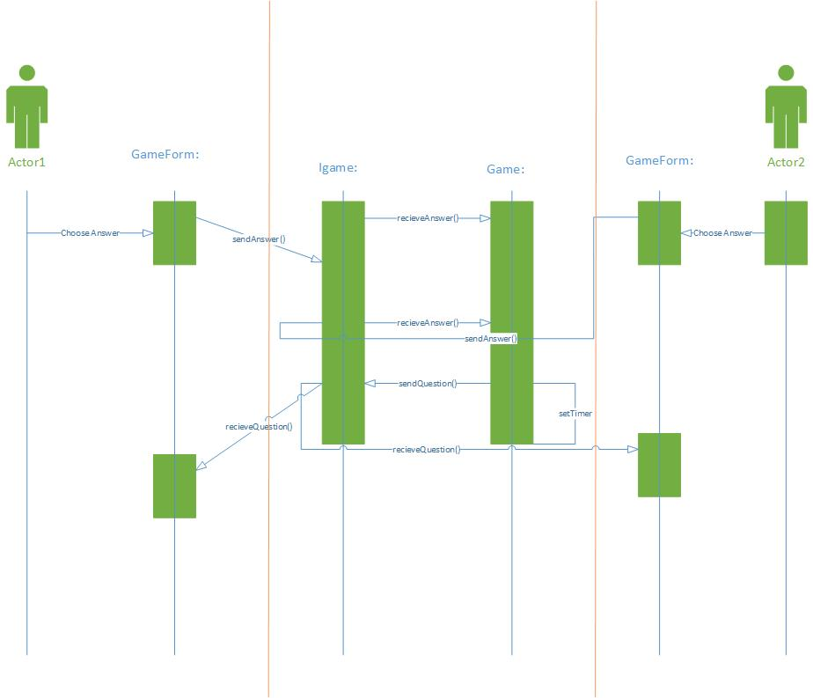

## 4.3 Win/Lose/Draw

